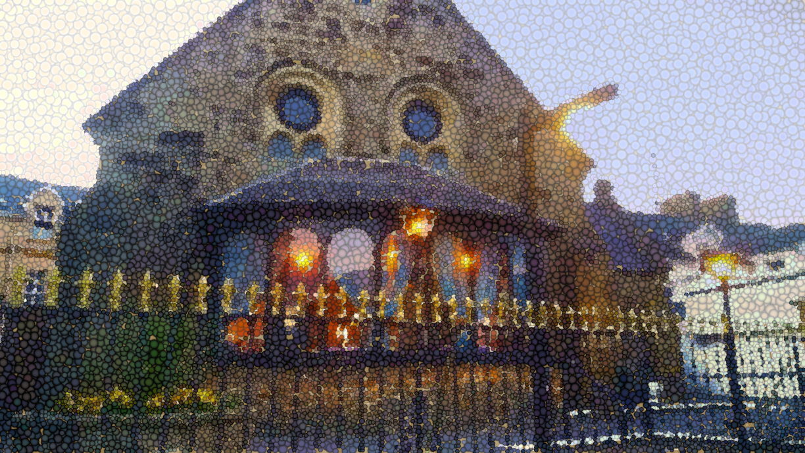***STORYBOARD | The Blue Leaf Restaurant | Page one***



**>>> home**

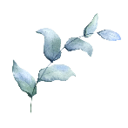

Home | About Us | Menu | Gallery

The Blue Leaf

**Seafood | Pasta | Steak | Chicken : | : Takeaway · Dine in · Outdoor seating**

Restaurant



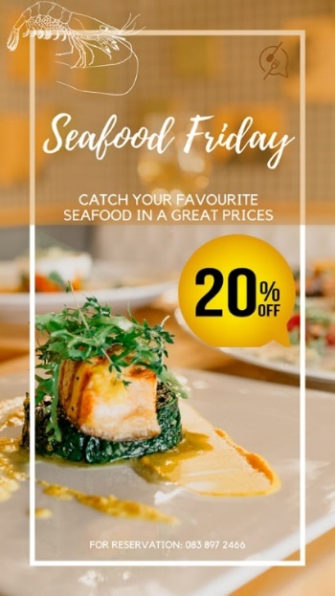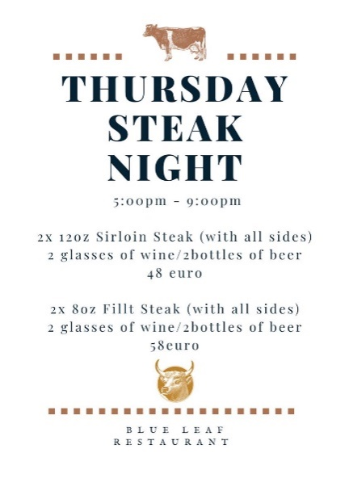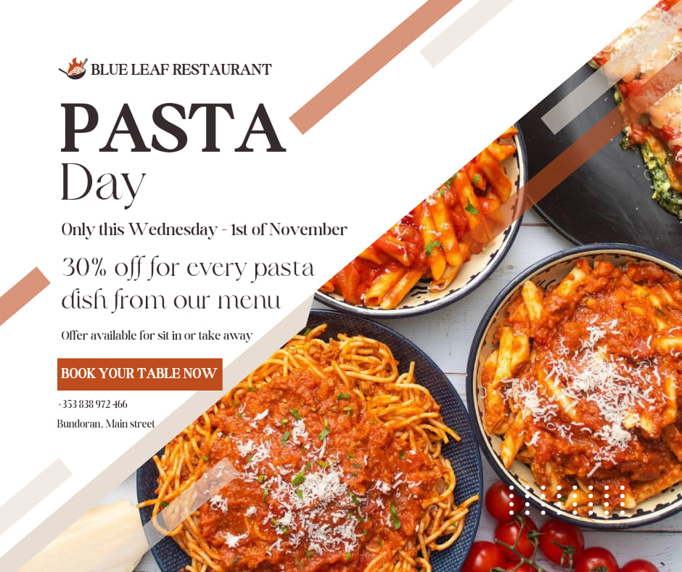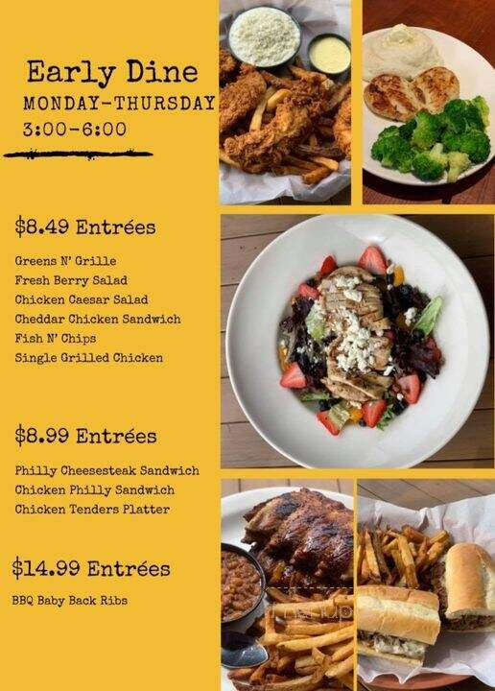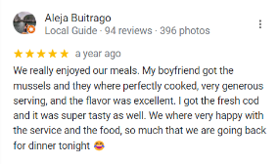





BUY A VOUCHER

| 083 897 2466 | [blueleaf.bundoran@gmail.com](mailto:blueleaf.bundoran@gmail.com) | Main Street Bundoran, Ireland F94 KT20

***STORYBOARD | The Blue Leaf Restaurant | Page two***



**>>> About Us**



Home | About Us | Menu | Gallery

The Blue Leaf

***Restaurant***

Established where before was an old Methodist Church (Campbell’s Memorial Methodist Church built by Thomas Elliott in 1888). Its Gothic windows and glazed porch facing onto the street give the building its unique character. In 1980 it was converted into a coffee shop. In March 2018 the building was running by new owners and renamed The Blue Leaf Restaurant.

Since than it has been synonymous of highest quality, generous and tasty food. All on the menu is well-chosen. As a small family restaurant, we have known how much important give supporter to Irish producers, because of that we using fresh local ingredients in our dishes.

The atmosphere enabling to our customers an exceptional dining experience ideal spot for a dinner or to celebrate special occasions in Bundoran.

The Blue Leaf running and managed by Ania Gapa-Chochorowska and Chef de Cuisine Grzegorz Chochorowski.

***STORYBOARD | The Blue Leaf Restaurant | Page three***



**>>> Menu**



Home | About Us | Menu | Gallery

The Blue Leaf

***Restaurant***

| Dinner In Menu | Takeaway Menu

| Starts

| Main

| Desert

| Kids Menu

| Wine

| Soft Drinks

| Coffee

| Bear

***STORYBOARD | The Blue Leaf Restaurant | Page three***



**>>> Menu**



Home | About Us | Menu | Gallery

The Blue Leaf

***Restaurant***

| Dinner In Menu | Takeaway Menu

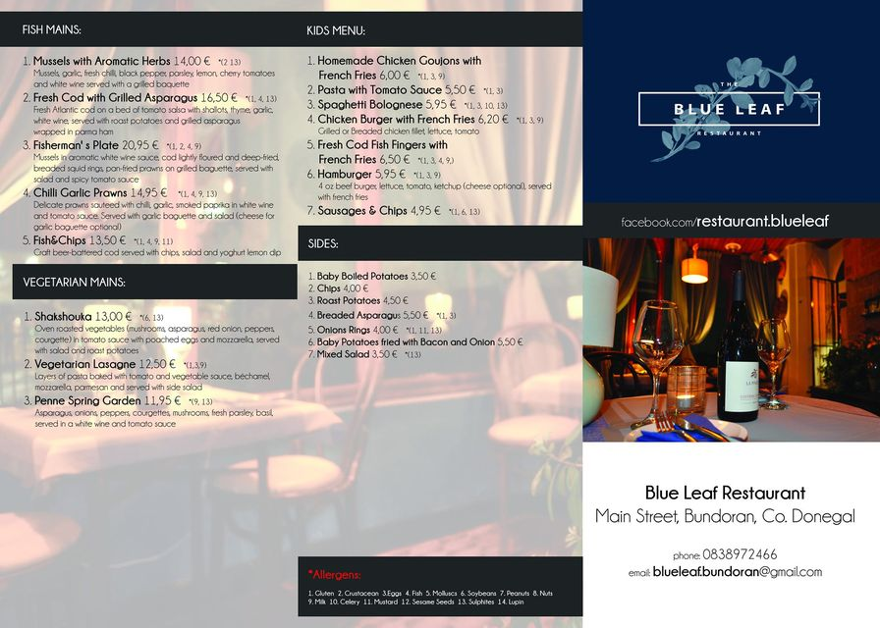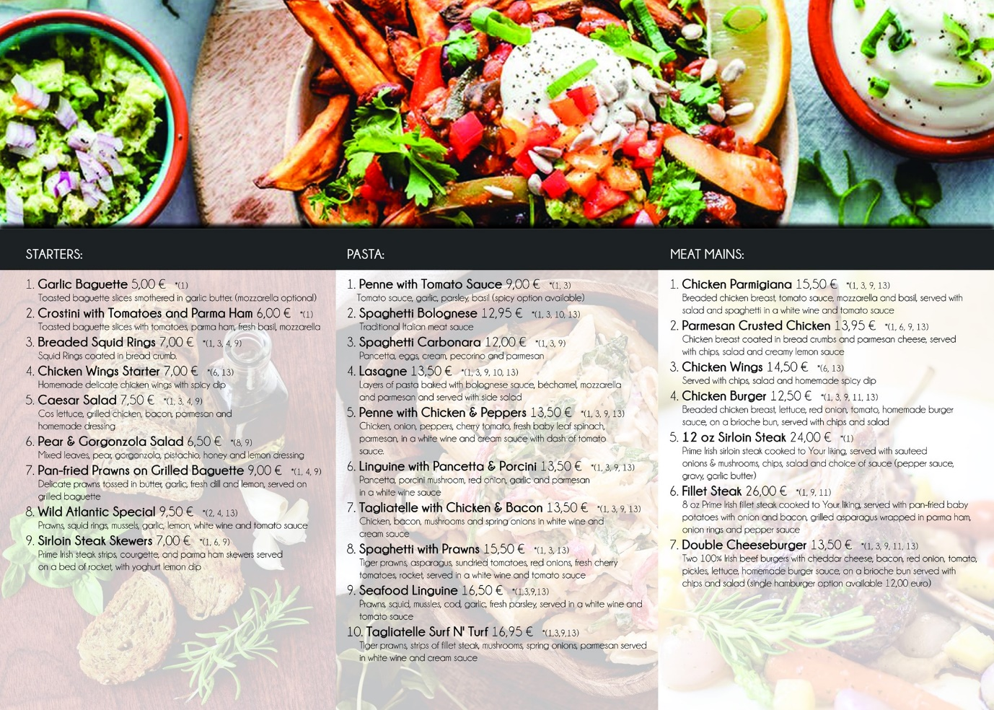

***STORYBOARD | The Blue Leaf Restaurant | Page Four***



***STORYBOARD | The Blue Leaf Restaurant | Page Four***



**>>> Gallery**



Home | About Us | Menu | Gallery

The Blue Leaf

***Restaurant***

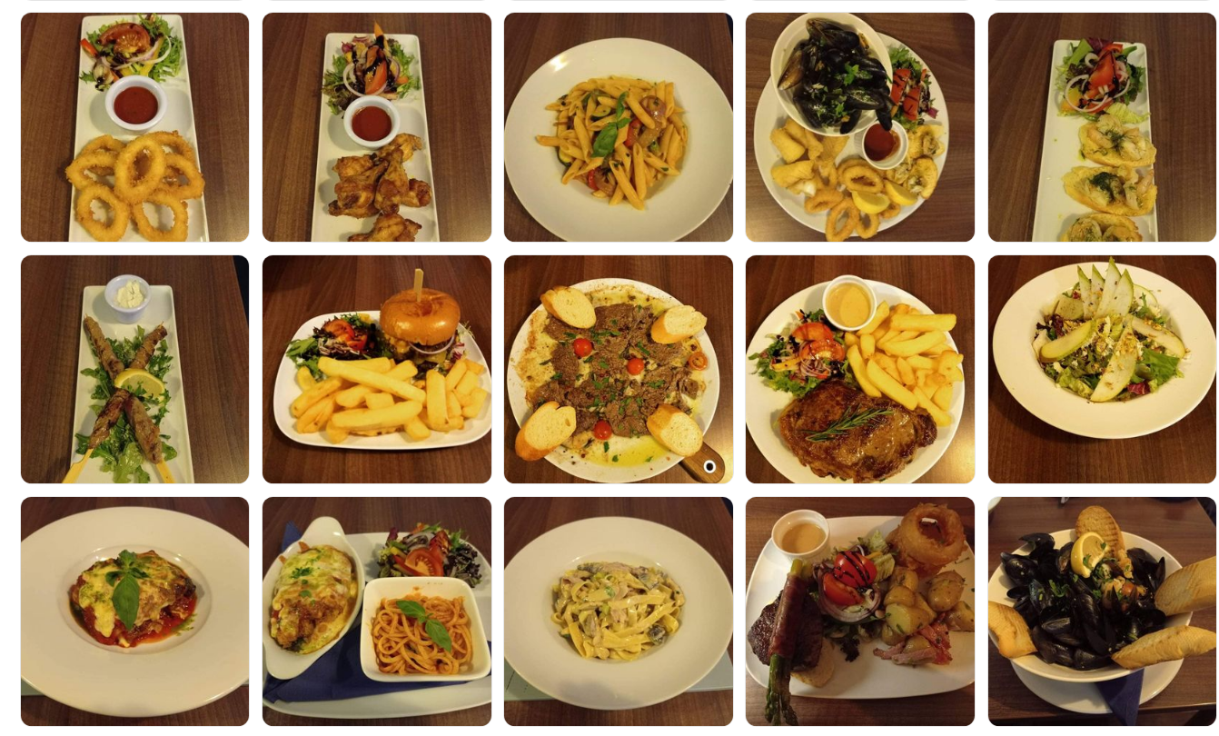

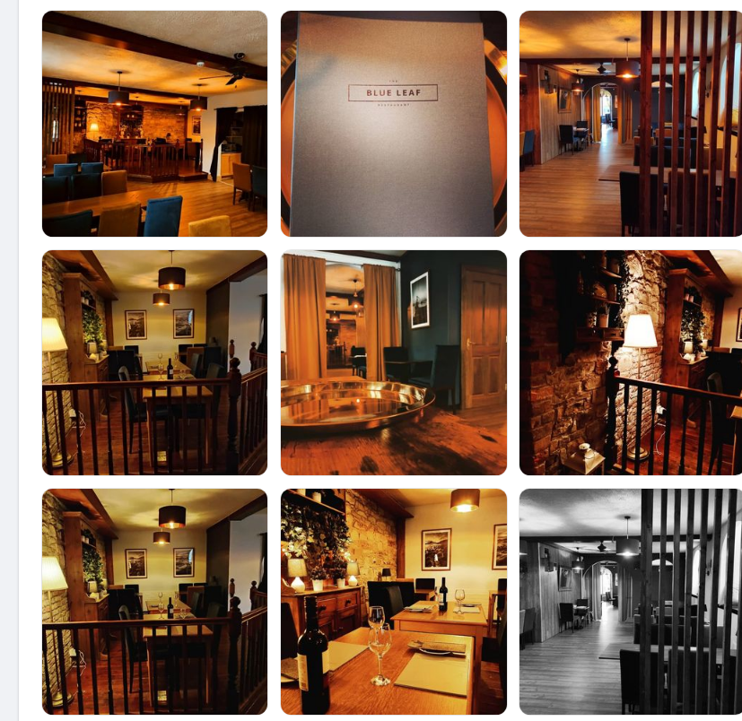

***STORYBOARD | The Blue Leaf Restaurant | Template background I***



**>>> *Template I***

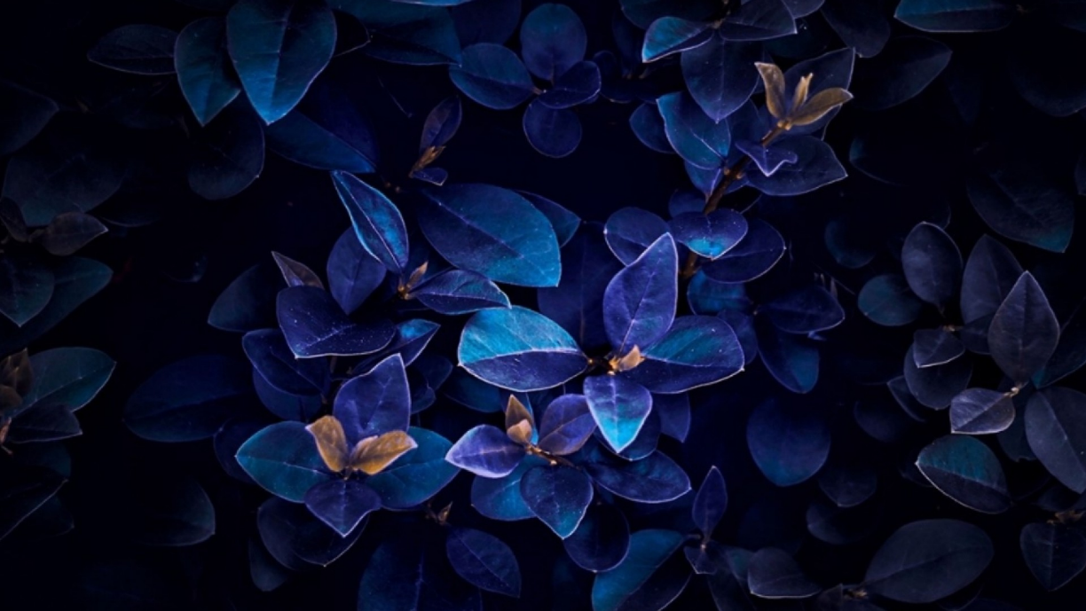

Home | About Us | Menu | Gallery

The Blue Leaf

***Restaurant***

***STORYBOARD | The Blue Leaf Restaurant | Template background II***



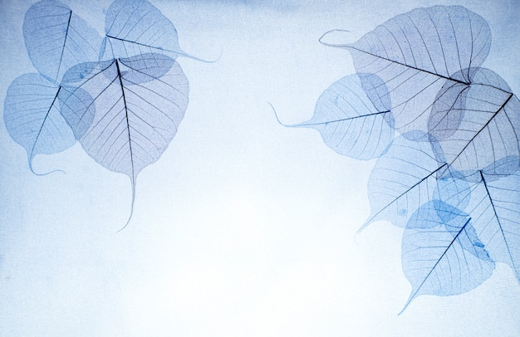 **>>> *Template II***



Home | About Us | Menu | Gallery

The Blue Leaf

***Restaurant***

***STORYBOARD | The Blue Leaf Restaurant | Template background III***



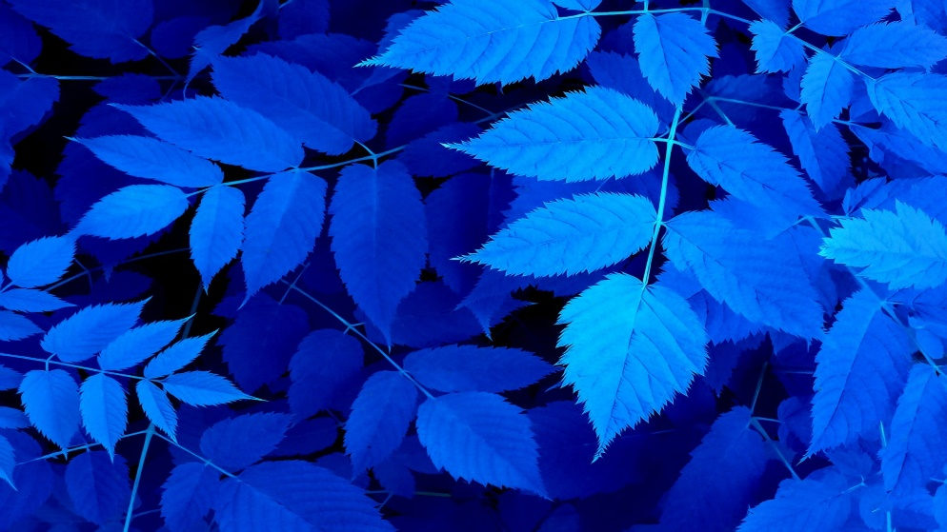 **>>> *Template III***



Home | About Us | Menu | Gallery

The Blue Leaf

***Restaurant***

***STORYBOARD | The Blue Leaf Restaurant | Template background IV***



**>>> *Template IV***

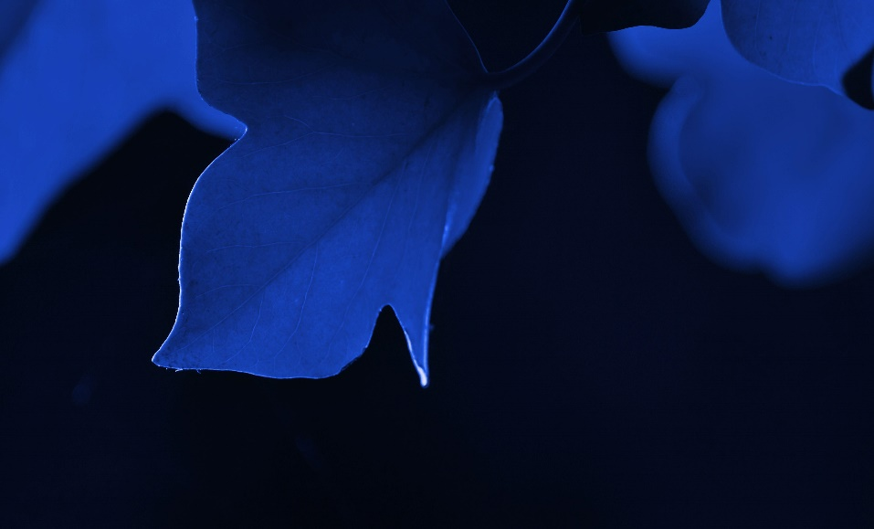

Home | About Us | Menu | Gallery

The Blue Leaf

***Restaurant***

***STORYBOARD | The Blue Leaf Restaurant | Template background V***



**>>> *Template V***

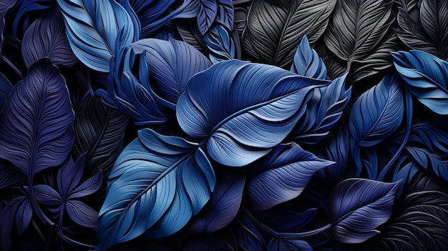

Home | About Us | Menu | Gallery

The Blue Leaf

***Restaurant***

***STORYBOARD | The Blue Leaf Restaurant | Template background VI***



**>>> *Template VI***



Home | About Us | Menu | Gallery

The Blue Leaf

***Restaurant***

***STORYBOARD | The Blue Leaf Restaurant | Template background VI***



 **>>> *Template VI***



Home | About Us | Menu | Gallery

The Blue Leaf

***Restaurant***